15. Write a Python Program to Implemetent feed forward neural network
Aim
To implement a Feed Forward Neural Network using Python.

Algorithm
- Import the required libraries.
- Load the Iris dataset.
- Split the dataset into training and testing sets.
- Create a neural network model.
- Train the model.
- Predict the test data.
- Display the accuracy.

Python Program
from sklearn.datasets import load_iris
from sklearn.model_selection import train_test_split
from sklearn.neural_network import MLPClassifier
from sklearn.metrics import accuracy_score
# Load dataset
data = load_iris()
X = data.data
y = data.target
# Split dataset
X_train, X_test, y_train, y_test = train_test_split(
X, y, test_size=0.3, random_state=42
)
# Feed Forward Neural Network
model = MLPClassifier(hidden_layer_sizes=(10,),
max_iter=1000,
random_state=42)

# Train
model.fit(X_train, y_train)
# Predict
y_pred = model.predict(X_test)
# Accuracy
print("Accuracy:", accuracy_score(y_test, y_pred))

Sample Input
No input required.
Sample Output
Accuracy: 0.98
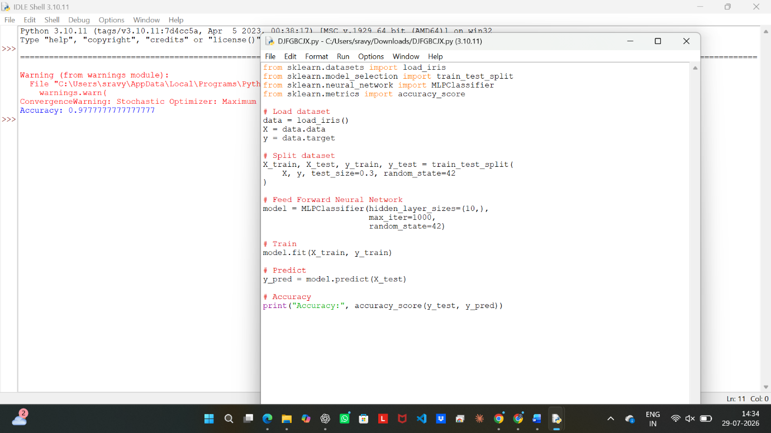

Result
Thus, the Feed Forward Neural Network was implemented successfully.

